Computer Networks Laboratory Week 6

Name : Tanishq Vyas
SRN : PES1201800125
Section : H
Semester : 5
Branch : CSE

TASK 1

Configurations :

Name | IP Address | Gateway | FastEthernet0/0 | FastEthernet0/1
PC0 | 10.0.0.2 | 10.0.0.1 | N/A | N/A
PC1 | 10.0.0.3 | 10.0.0.1 | N/A | N/A
PC2 | 30.0.0.2 | 30.0.0.1 | N/A | N/A
PC3 | 30.0.0.3 | 30.0.0.1 | N/A | N/A
Router 0 | N/A | N/A | 10.0.0.1 | 20.0.0.1
Router 1 | N/A | N/A | 30.0.0.1 | 20.0.0.2

Routing Table Entries :

Name | Network | Next Hop
Router 0 | 30.0.0.0 | 20.0.0.2
Router 1 | 10.0.0.0 | 20.0.0.1

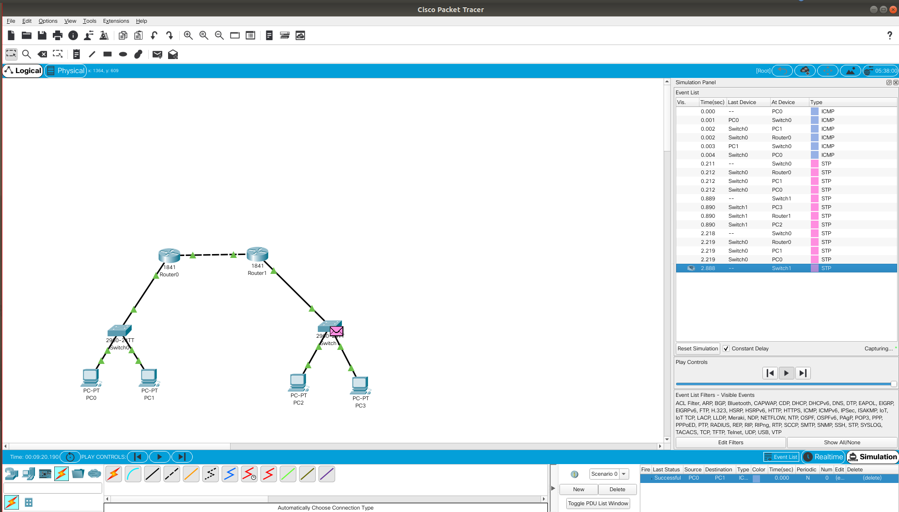
Fig : Packet Tracer Capture for Topology 1

TASK 2

Configurations :

Name | IP Address | Gateway | FastEthernet0/0 | FastEthernet0/1 | FastEthernet0/0/0
PC0 | 10.0.0.2 | 10.0.0.1 | N/A | N/A | N/A
PC1 | 10.0.0.3 | 10.0.0.1 | N/A | N/A | N/A
PC2 | 20.0.0.2 | 20.0.0.1 | N/A | N/A | N/A
PC3 | 30.0.0.2 | 30.0.0.1 | N/A | N/A | N/A
PC4 | 30.0.0.3 | 30.0.0.1 | N/A | N/A | N/A
Router 0 | N/A | N/A | 10.0.0.1 | 40.0.0.1 | N/A
Router 1 | N/A | N/A | 30.0.0.1 | 40.0.0.2 | 50.0.0.2
Router 2 | N/A | N/A | 20.0.0.1 | 50.0.0.1 | N/A

Routing Table Entries :

Name | Network | Next Hop
Router 0 | 20.0.0.0 | 40.0.0.2
Router 0 | 30.0.0.0 | 40.0.0.2
Router 1 | 10.0.0.0 | 40.0.0.1
Router 1 | 20.0.0.0 | 50.0.0.1
Router 2 | 10.0.0.0 | 50.0.0.2
Router 2 | 30.0.0.0 | 50.0.0.2

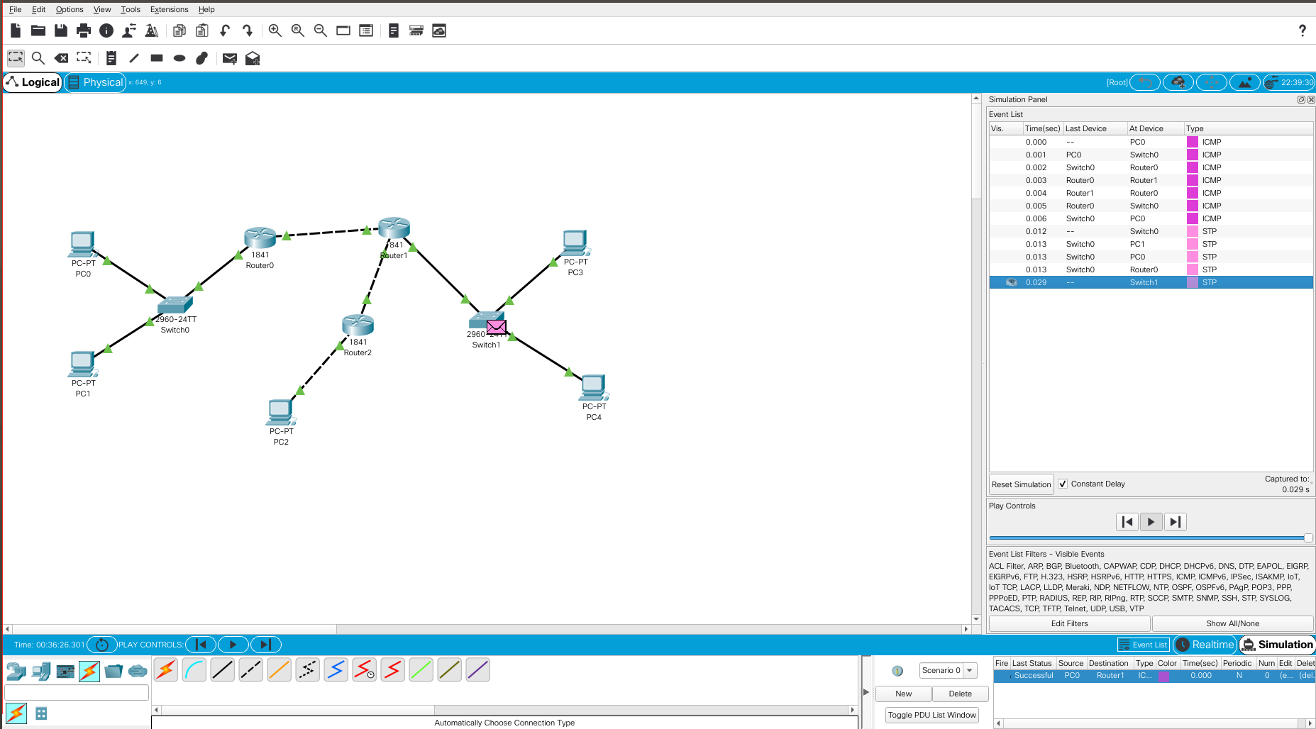
Fig : Packet Tracer Capture for Topology 2

